**ENQUIRY FOR PREQUALIFICATION (NO. PRQ/JPT/27/23)**

**STRUCTURES A & E, MELLITAH COMPLEX EXPANSION & CO2 MANAGEMENT INTEGRATED DEVELOPMENT PROJECT**

**C.A.R Insurance**

Mellitah Oil & Gas B.V. (MOG) intends to enhence its production by adding new offshore and onshore production facilities, under STRUCTURES A & E, MELLITAH COMPLEX EXPANSION & CO2 MANAGEMENT INTEGRATED Development Project. The Overall Development will be implemented on individual projects basis. MOG would like to invite the interested **C.A.R Insurers** who are qualified and experienced in this field to express their interest to participate in the Tender of C.A.R Insurance for “STRUCTURES A & E, MELLITAH COMPLEX EXPANSION & CO2 MANAGEMENT INTEGRATED DEVELOPMENT PROJECT”, by submitting a Prequalification request to Company. Information about the Project and the Participation requirements are detailed herefollowing.

**PROJECT DESCRIPTION**

Company is considering the development scenario for A-Structure located in the Libyan offshore (Area D) envisages a dry tree/fixed platform (WHPA) development in synergy with the existing platform of Sabratha, while the E-Structure will be developed using an independent fixed production platform (PPE) along with subsea wells.

E-Structure is located (see figure below) in the central-eastern part of the Area D (ex NC41 area), about 130 Km far from the Libyan coast, in a water depth ranging from 205 to 235m, while A-Structure is in the central-western part of the area, approximately 80 Km from Libyan coast, where water depth is ranging between 95 and 105m.

A new 36” gas sealine about 30 km long (size and distance to confirmed) to deliver E Structure production to existing 36” gas export sealine from Sabratha Platform to Mellitah Complex.

A new 10” condensate sealine about 30 km long (size and distance to confirmed) to deliver E Structure production to existing 10” condensate export sealine from Sabratha Platform to Mellitah Complex.

A new 18” multiphase flow line from WHPA to Sabratha Platform and 16” multi phase gathering line to tie-back the subsea wells to PPE.

Sabratha Platform modification (manifold and separation for A Structure production).

New 4th SRU train and associated new utilities together with upgrade of the existing gas trains and existing SRU trains and associated utility systems with the purpose of improving reliability, availability, productivity, efficiency and extending design life in line with established production profile.

CO2 management through dehydration and compression in Mellitah and injection in 3 wells in BES field through the installation of a new sealine (16”) 110 km from shore to BES field.

The overall Project scheme is summarized in the sketch drawing below.

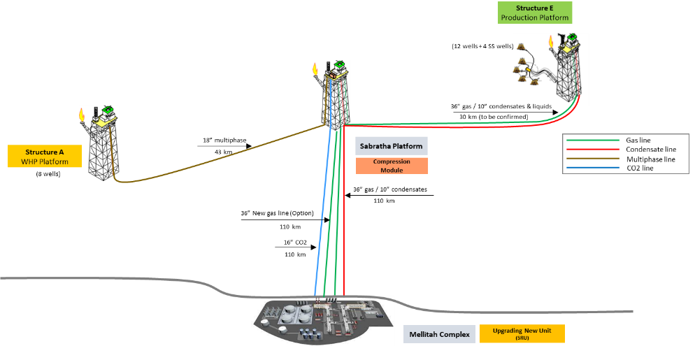

A-Structure and E-Structure, Mellitah Complex Expansion & CO2 Management Development Scheme

**SCOPE OF WORK**

COMPANY is attending to put in place a framework contract for the provision of independent professional insurance brokerage and insurance advice services for a range of insurances for “STRUCTURES A & E, MELLITAH COMPLEX EXPANSION & CO2 MANAGEMENT INTEGRATED DEVELOPMENT PROJECT”.

The selected professional insurer broker shall provide all services for all types of CAR and third party liability insurances coverage required for this project.

Important

Mellitah Oil & Gas BV reserves the right to change the contractual Strategy during or after the course of the Pre-Qualification without notifying the Applicant.

**Technical Information Required**

**For**

**C.A.R. Insurance**

1. Project DEVELOPMENT **SCENARIO**

## Offshore Part:

### E-Structure Production Platform (PPE):

The PPE Platform is an eight legs production platform with twenty (20) slots. Pre-drilling activities are foreseen for the platform wells through the installation of a pre-drilling template with 20 slots.

The PPE platform is a treatment and compression platform to be installed in 218m water depth. Topside is componsed of a Single Integrated Deck, Flare, Living Quarter, and Compression Module.

A Single Integrated Deck (SID) configuration is requested in order to minimize the offshore installation and hook-up activities. SID, Flare and LQ may be installed separately (i.e. 3 offshore lifts) (to be confimred).

The SID will host main process and utilities and is endowed with six levels.

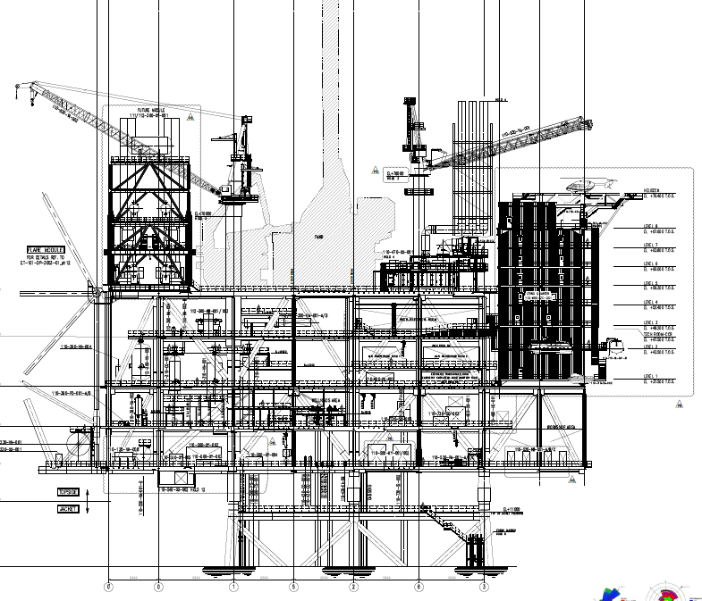

The Platform will be designed to receive and treat the well fluid coming from both wells drilled from platform and subsea wells. The treated gas and the oil/condensate are then sent via gas and condenstae sealines to existing sealines between Sabartha Platform & Mellitah Complex.

The well fluid is treated by means of two trains (2 x 50%) where separation of gas from the associated condensate / water occurs and gas compression. The installation of a raw gas compression system is also foreseen.

The separated condensate is partially stabilized by means of flash operation in a single train.

PPE will include a Living quarter (120 people) with upper mounted helideck as a cantilevered structure on the side of the platform.

The platform will be designed to install a Fast Moving Work Over Rig (FMWR) for completion and work over (PPE EPIC scope will include transferred from WHPA and install it on PPE).

Expected overall topside dry weight is around 24000 t (excluding Fast Moving Workover Rig). (This figure is preliminary and to be confirmed). Expected weight of SID in installation conditions is about 17500 t (This figure is preliminary and to be confirmed).

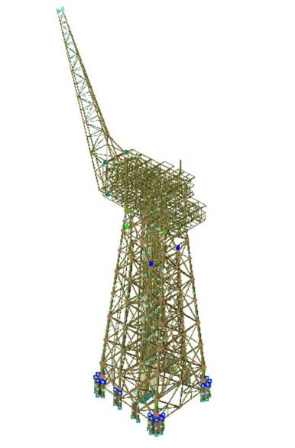

The jacket is a lattice structure with eight legs, to be installed by means of launching operations. Platform foundation is composed by piles.

Overall jacket weight in launch configuration is about 45000 t (Provisional data; To be confirmed).

### A-Structure Well Head PLatform (WHPA):

The A Structure development envisages the exploitation of the gas and associated condensate through a wellhead platform (WHPA), located in approximately 96 m water depth at 43 km from Sabratha Platform.

The WHPA Platform is a four legs wellhead platform. In particular the WHPA it is structured in three main levels.

A small living quarter (for 20 people) with upper mounted helideck are visible in reference plot plan as cantilevered structure on the east side of the platform.

WHPA platform will be minimum manned platform (for 20 people) and shall be controlled/operated only offshore by an Integrated Control and Safety System installed on WHPA platform. At the same time, it can be supervised and controlled by the aid of MTU of SCADA system will be installed on Sabratha Platform.

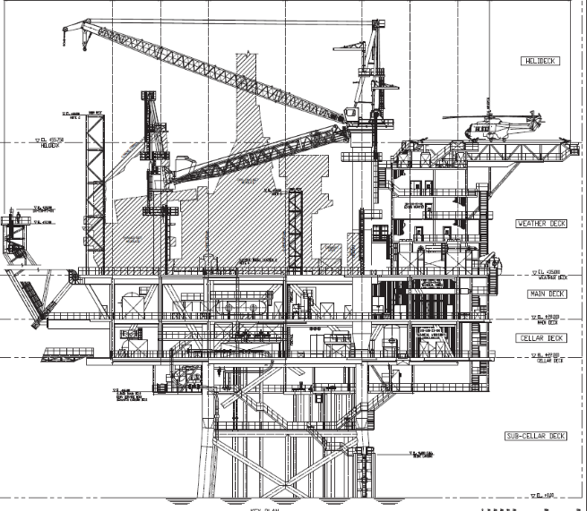

The jacket is a lattice structure with four legs and six plans, to be installed by means of launching operations.



**Pre-drilling** activities are foreseen for the 8 wells through the installation of a pre-drilling **template** with **10 slots**. The platform will be designed to install a Fast Moving Work Over Rig (FMWR) for completion and work over. The detailed design, procurment, transportation, and installation of the Fast Moving Work Over Rig (FMWR) will be part of the WHPA EPC Contract.

The platform is designed to handle the fluid coming from 8 gas/condensate wells. The reservoir fluids are conveyed from the platform wells to the Production/Test Manifolds via fully rated pipelines (wellhead shut-in pressure). The production manifold connects the flowlines to the sealine to export the profuction via 18” multiphase sealine to the existing Sabratha Platform for further treatment together with Sabratha well fluid.

A fibre optic cable will be laid to connect WHPA and Sabratha Platform.

### Sabratha Platform Modifications:

Sabratha platform is an existing platform included in the Structure C, located in the Area D, offshore Libya, in a water depth ranging from 190 to 205 m, about 100 km from the closest point on the coast.

Sabratha Platform modifications scope will be limited add the equipment needed on Sabratha platform to handle the production from WHPA Platform. This mainly include one new slug catcher separator and the relevant utility units. New risers and J-tubes and upgrading of the ICSS & Telecommunication systems and subsea topside equipments.

### Subsea & Sealines:

The subsea systems and sealines work package scope includes the following componenets:

* Carbon Steel Sealines:
* 36”, around 30 km from PPE to Sabratha Platform Export sealine (gas)
* 10”, around 30 km from PPE to Sabratha Platform Export sealine (condensate)
* 16”, 108 km from Mellitah Complex to Sabratha Platform (CO2)
* Cladded Sealines:
* 18”, 43 km from WHPA to Sabratha Platform (multiphase)
* 16” production line and a test line 6”, 6.8 km from E platform to manifold at North Cluster (multiphase)
* 6”, 15.4 km production/test line from manifold at North Cluster to PLEM of the single well EW01 at West Cluster (multiphase)
* 4”, 22.2 km service line from PPE to PLEM near EW01 (via North Cluster manifold)
* Risers & J-tubes
* Subsea Production systems:
* 5 Horizontal XTs with multiphase meter and related protective structures & foundations
* 1 Subsea Manifold and related protective structures & foundations
* 1 Subsea PLEM and related protective structures & foundations
* PLETs and related protective structures
* SSIVs systems and related protective structures & foundations (number of SSIVs will be confirmed later)
* Umbilicals / FOC
* Rigid jumper and FLs
* Subsea production controls system.

## Onshore Part:

Mellitah Complex comprises the Mellitah Plant, which processes raw gas and unstabilized condensate from the Sabratha platform, and the Wafa Coastal Plant which receives sales gas and processes unstabilized liquids from the Wafa Desert Plant.

For A & Structures, the following upgrading and modification to existing Mellitah Complex Facilities are foreseen:

### Upgrading and modification to existing Mellitah Complex Facilities.

The project includes necessary modification required to MCX process facilities resulting from change in raw composition from A&E structures, and the impact of change of B.L. conditions (hydraulic profile) at Mellitah plant.

### SRU Train

To ensure that sufficient capacity is always available to process the total Sour Gas stream a new 4th Sulphur Recovery Train is required. This train will be on “cold stand‐by” and be suitable for operation in parallel with the three existing Suphur Recovery Trains.

### CO2 Management

In addition, the project scope also incorporates CO2 management. The CO2, which is currently vented from the Incinerators in the SRUs, is compressed, dehydrated and re‐injected in the Bahr Essalam field.

### Utilities:

The following Utilities are required:

* UNIT 60‐460 New Air System
* UNIT 60‐500 New Sea Water & Hypochlorite System
* UNIT 60‐520 New Cooling Water System
* UNIT 60‐530 New Demineralized Water System
* UNIT 60‐540 New Open Drain System
* UNIT 60‐550 New Process Area HC Closed Drain System
* UNIT 60‐560 New Waste Water System
* UNIT 60‐600 New Inert Gas System
* UNIT 60‐620 Steam & Condensate System
* New 4th GTG to cover the new total power demand. The new GTG will be located in the Wafa Coastal Plant as part of the existing power generation system.
* UNIT 4E‐220 New Fuel Gas System
* UNIT 60‐650 New Caustic and Acid Storage

The new utilities shall be interconnected with existing MCX utilities through normally no flow lines (NNF), such that, if necessary, the two systems can operate in parallel.

# Execution Strategy

The Overall Development will be implemented on individual projects basis. The contracting strategy forsees the following main EPCIC/EPC contracts:

* Pre-Drilling Template
* Platform “E”
* Platform “A”, Sabratha Modifications and FMWR
* Subsea & Sealines
* Onshore

# Project SCHEDULE

The overall execution schesdule is expected to start on 4Q 2023 and and ready to be started-up xQ 2026 for Structure “A” and xQ 2027 for Structure “E”.