|  |  |  |  |  |  |  |  |  |  |
| --- | --- | --- | --- | --- | --- | --- | --- | --- | --- |
|  | |  | |  | | | | | |
| 9 Sheets | | 3417-000-A-SP-MOG-00110 | | | |
| BOURI GAS UTILIZATION PROJECT (BGUP)  BASE CASE 42% CO2 | | | | | | | | | |
| DOCUMENT TYPE: Technical Note  BRIEF TECHNICAL NOTE FOR CAR INSURANCE P.A. | | | | | | | | | |
| 3417-000-A-SP-MOG-00110 | | | | | | | | | |
|  |  | |  | |  | |  |  |  |
| A07 | 13/Sept/22 | | Issue for use | | BGUP team | |  |  |  |
| A06 | 13/May/22 | | Issue for use | | BGUP team | | IR/FD | ND | AE |
| A05 | 11/June/20 | | Issue for use | | BGUP team | | IR/KB | ND | AE |
| **Rev** | **Date** | | **Description** | | **Prepared** | | **Checked** | **Approved** | **Endorsed** |

Hold Record

| Hold No. | Section | Description of Hold |
| --- | --- | --- |
|  |  |  |
|  |  |  |
|  |  |  |
|  |  |  |
|  |  |  |
|  |  |  |
|  |  |  |
|  |  |  |

TABLE OF CONTENTS

1 INTRODUCTION 4

1.1 Existing Bouri Offshore Facilities Overview 4

1.2 Project Objectives 4

1.3 BGUP Facilities 4

2 Execution strategy 7

3 PROJECT SCHEDULE 8

4 Company purchased items 9

# INTRODUCTION

## Existing Bouri Offshore Facilities Overview

The Bouri oil field is in the Mediterranean Sea, approximately 120 km northwest of Tripoli. Currently it is producing oil at a rate of approx. 30,000 bopd of low API gravity crude (25°-27° API), associated gas, and produced water from facilities located on two existing platforms, DP3 and DP4, operated by Mellitah Oil and Gas (MOG).

DP3 is a satellite production platform with 21 platform wells and 3 subsea wells connected to a single stage of 2-phase separation. Associated gas (approx. 60 MMscfd) is currently flared via a dedicated flare boom. Production liquids (containing crude oil and water) free flow to the 2nd stage separators on the main DP4 processing platform via an existing 12” x 8 km marine pipeline.

DP4 has 42 connected platform wells and handles production fluids from these along with the production liquids from DP3 via two trains. These trains were originally designed to operate in parallel to each produce 60,000 bopd for a total platform capacity of 120,000 bpd (i.e. 2 x 50%). Each train consists of three stages of 3-phase separation and an electrostatic desalter. Stabilised oil is pumped to an existing FSU called ‘Gaza’ via 1 x 100% 16” x 3 km marine pipeline. Associated gas (approx. 60 MMscfd) is currently flared via a dedicated flare boom. Produced water is treated to reduce its oil content to 15 ppm and either re-injected into the Bouri reservoir or discharged to sea.

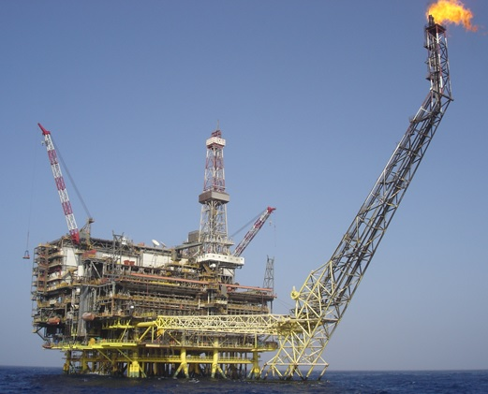

Figure ‑ - DP4 Platform

## Project Objectives

The objective of this PROJECT is to supply and install a Gas Recovery Module (GRM) and ancillary structures/modules at the DP4 facility together with the associated gathering network and supporting infrastructure to export gas to the Mellitah Complex via the existing Sabratha network. This WORK includes the necessary upgrades at DP4 Living Quarters to ensure full alignment with all relevant gas production safety requirements.

## BGUP Facilities

BGUP reactivation study (performed by Wood in 2019) resulted in a simplified process arrangement for the Bouri gas utilisation project with a gas recovery module being installed on the DP4 platform alongside a series of essential brownfield upgrades to both DP3 and DP4.

Raw gas taken off the DP3 separator will be transferred to DP4, via a new 14" x 8km Inconel clad pipeline. To accommodate this, the following modifications are proposed for the DP3 platform:

* Process tie-ins from existing production separator, test separator and gas scrubber
* A small deck extension to accommodate a new pig launcher and riser for the infield pipeline

The DP3 raw gas will be mixed with raw gas taken off the DP4 separator trains and this combined raw gas stream will be compressed via a 4-stage centrifugal compressor (General Electric BCL model) and dehydrated (via silica gel beds located between the 3rd and 4th stages) for export at approximately 110 barg. The compressor will be powered by a gas turbine (General Electric PGT25 SAC model) which cannot operate effectively using the available raw gas. Accordingly, higher quality fuel gas will be provided by taking a slip stream of the raw gas downstream of the dehydrators (between the 3rd and 4th compression stages) and passing it through an acid gas removal unit (membrane system). Condensate separated in the raw gas treatment and compression systems is spiked into oil train for export to the Gaza FSU. To accommodate this, the following modifications are proposed for the DP4 platform:

* Gas Recovery Module (single lift, NTE 5,000 Te)
* Process and Utility tie-ins to existing DP4 facilities
* Pig receiver and 14" riser to receive DP3 raw gas via infield pipeline
* Pig launcher and 10" riser to export Bouri raw gas to Sabratha platform

The pressurised raw gas from DP4 is transferred to Sabratha platform (via a new 10" x 20km carbon steel pipeline) for onward export to Mellitah onshore plant (via an existing 36" x 110km pipeline). The platforms are protected by an export and import SSIS for each pipeline together with Fibre Optic Cables for interconnection between DP3, DP4 and Sabratha Platforms.

Minor activities are foreseen on Sabratha Platform including a replacement of existing 10” ESDV, HPU and TUTU for the new 10” SSIV is also considered.

The proposed field layout incorporating the BGUP facilities is shown in Figure 1‑2.

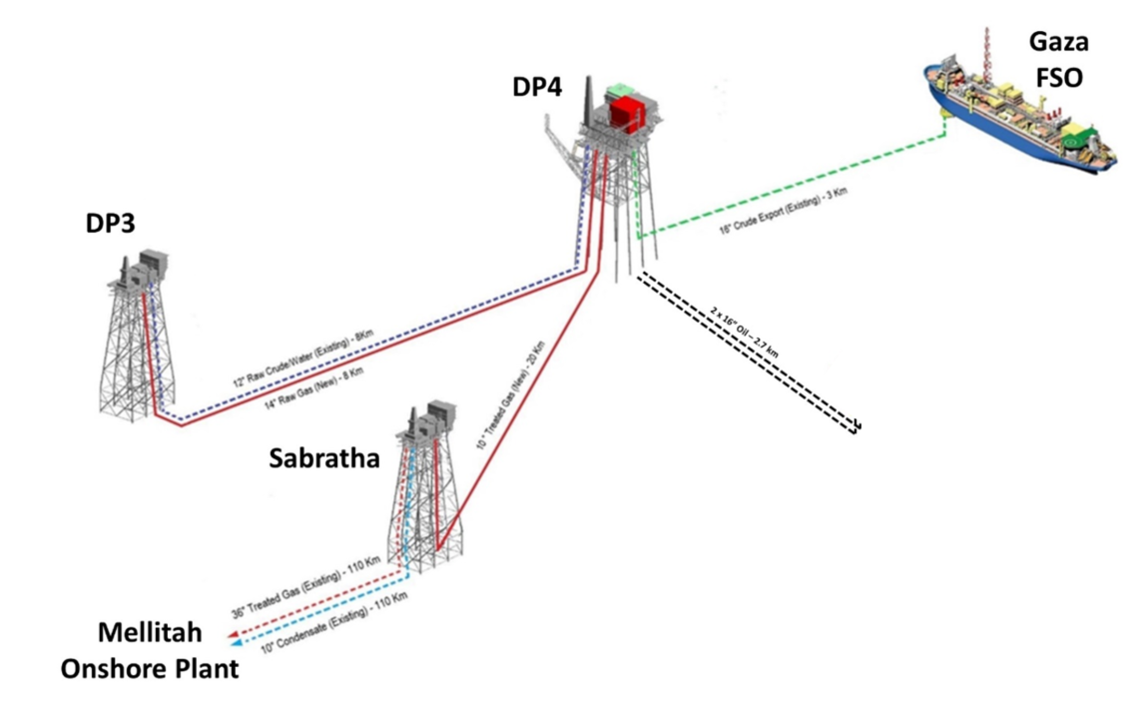

Figure ‑ - Bouri Field Layout Including Proposed BGUP Facilities Upgrades

The Subsea System BGUP upgrade are illustrated in Figure 1‑3 and it consists of the following main systems:

* 14” Raw Gas, Carbon steel internally cladded sealine from DP3 to DP4 Platform;
* 10” Export Gas, Carbon Steel sealine from DP4 to Sabratha Platform;
* Fibre Optic Cable (FOC) from DP3 to DP4 Platform;
* Fibre Optic Cable (FOC) from DP4 to Sabratha Platform;
* Subsea Safety Isolation Valves Systems (SSISs), including SSIV (subsea safety isolation valves) modules, umbilicals for SSIVs control and topside control panel and HPU, on start and arrival of each sealine close to DP3, DP4 and Sabratha risers;
* Risers and J-Tubes for the connection of new sealines including supports on existing platforms, protection structures, FOC and umbilicals where required as described below:

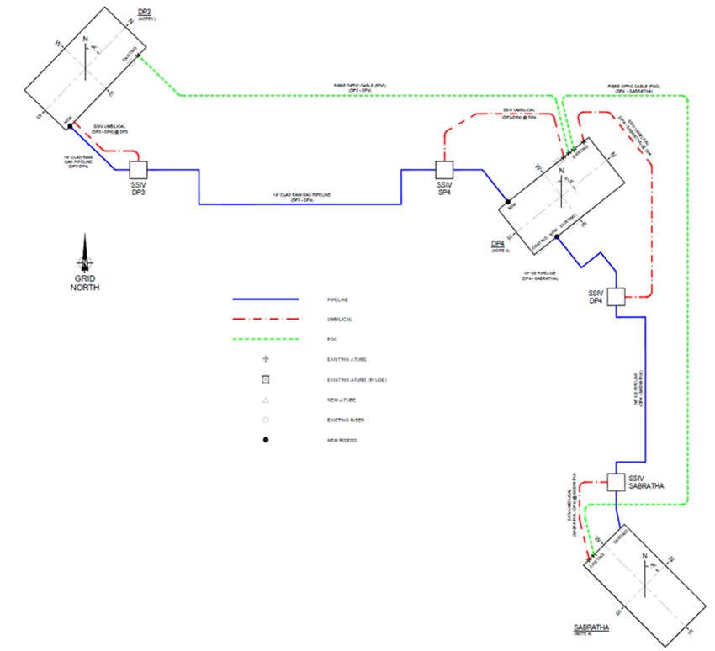

Figure ‑ - Subsea System BGUP upgrade Schematic

# Execution strategy

EPCIC CONTRACTOR is responsible for the detailed Engineering, Procurement, Construction, Transportation, Installation, Hook-up, Pre-Commissioning, Mechanical completion, Commissioning, Start-Up and Performance Testing of all facilities associated with the Bouri Gas Utilisation Project. This includes all necessary activities to obtain Independent Verification Body (IVB), Marine Warranty Surveyor (MWS) and COMPANY approval for the planning and execution of WORKS and safe operation of the FACILITY.

FEED update "BGUP Base Case 42% CO2" has been subject to third party appraisal carried out by Bureau Veritas. The FEED has been performed by Wood and Eni Progetti respectively for the topside and the subsea scope of the Project.

Prior to commencement of EPCIC activities, but after the award, a full endorsement of the Company FEED design is required by CONTRACTOR.

Following the aforementioned suspension of the Project in 2011, a large proportion of detailed engineering and procurement related activities were close to completion, as a result, some equipment and bulk materials are readily available to use subject to reconditioning, upgrading and modification and recertification. To maximise the use of already procured material, EPCIC Contractor is to accept the ‘as it is’ condition and utilize availability of existing equipment and where necessary carry out appropriate testing and inspection prior to acceptance. To support this, an assessment was carried out during the re-activation study to establish the level of completion of engineering, fabrication and procurement for equipment items and bulk material (see Section 4).

BGUP EPCIC Scope of work includes both greenfield activities (i.e. those associated with the new gas recovery module and new sealines System) and pre/post-installation brownfield activities to support process tie-ins and upgrades to existing utilities. An extensive Offshore hook-up campaign shall be performed by the EPCIC CONTRACTOR to execute the brownfield modification on the existing offshore facilities.

The table here below provides a brief description of EPCIC CONTRACTOR scope of WORK, which shall not be considered as exhaustive.



Figure ‑ Project Contracting Strategy Summary

# 

# PROJECT SCHEDULE

A Project schedule between 32 to 36 months is expected from the Contract Award to the start-up.

An Offshore campaign duration between 12 and 16 months is foreseen hook-up activities.

# Company purchased items

The BGUP project was initially sanctioned by MOG in 2007 and progressed to EPC phase in 2010 till the suspension of 2011. The Reactivation Study (2019) and FEED Update (2019/20) have been conducted with the key target to reuse all major tagged equipment and bulk previously manufactured/shipped and still required in the revised process flow scheme.

The FEED Update resulted in several changes from the original 2010 design, some of which require only modifications to be made to the existing BGUP equipment whilst other changes have made some equipment obsolete or not required. Those items will not provided as CPI and shall be retained in the warehouse.

All materials and equipment inspection, reconditioning, certification, upgrading and modification are include in the EPCIC scope of work.