ENQUIRY FOR PREQUALIFICATION (NO. PRQ/JPT/17/21)

STRUCTURES A & E, MELLITAH COMPLEX EXPANSION & CO2 MANAGEMENT INTEGRATED DEVELOPMENT PROJECT

SEALINES AND SUBSEA PRODUCTION SYSTEMS

Mellitah Oil & Gas B.V. (MOG) intends to enhence its production by adding new offshore and onshore production facilities, under STRUCTURES A & E, MELLITAH COMPLEX EXPANSION & CO2 MANAGEMENT INTEGRATED Development Project. The Overall Development will be implemented on individual projects basis; including an EPIC Project for SEALINES AND SUBSEA PRODUCTION SYSTEMS. MOG would like to invite the interested EPIC Contractors who are qualified and experienced in sealine and subsea production systems to express their interest to participate in the Tender of EPIC, by submitting a Prequalification request to Company. Information about the Project and the Participation requirements are detailed herefollowing.

PROJECT DESCRIPTION

The overall A & E structures develeopment project foresees the exploitation of Structures A and E located in the Libyan offshore area of NC 41 Block. The “A” Structure is in the central-western part of the area, approximately 80 Km from Libyan coast, where water depth is ranges between 95 and 105 m. While, “E” Structure is located in the central-eastern part of the area, about 130 Km far from the Libyan coast, in a water depth ranging from 205 to 235 m.

The selected offshore development scenario foresees:
- Structure A (WHPA): A New Wellhead Platform installed in 96m water depth (outside the scope of this pre-qualification)

- Structure E (PPE): A New Production Platform installed in 220 m water depth (outside the scope of this pre-qualification)

- Modification of Existing Sabratha Paltform (outside the scope of this pre-qualification)

- Sealines and Subsea Production Systems (inside the scope of this pre-qualification). Please refer to the “SCOPE OF WORK” section for further details.

- The onshore development scenario foresees upgrade of the existing onshore Mellitah Complex (outside the scope of this pre-qualification).

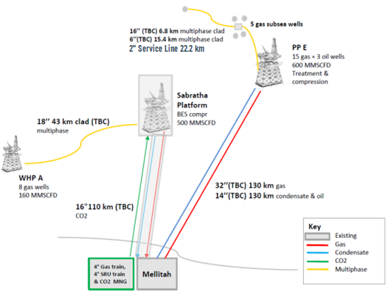
SCHEDULE
The EPIC execution is expected to start on 1Q 2023 and to be completed in 2Q 2025.

SCOPE OF WORK
It is a turnkey EPIC Contract. The EPIC Contractor’s Scope of Work includes Project Management, Surveys, Engineering, Procurement, Manufacturing/Construction, Fabrication, Testing, Transportation, Installation, Hook up, Pre-commissioning, commissioning, and Start-up of the following systems:

- Carbon Steel Sealines:
- 32” sealine, 130 km from PPE to Mellitah Complex (gas)
- 14” sealine (To be Confirmed), 130 km from PPE to Mellitah Complex (oil/condensate)
- 16” sealine, 110 km from Mellitah Complex to Sabratha Platform (CO2)

- Cladded Sealines:
- 18” sealine, 43 km from WHPA to Sabratha Platform (multiphase)
- 16” production line and a test line 6”, 6.8 km from E platform to manifold at North Cluster (multiphase)
- 6” sealine, 15.4 km production/test line from manifold at North Cluster to PLEM of the single well EW01 at West Cluster (multiphase)
- 4” sealine, 22.2 km service line from PPE to PLEM near EW01 at West Cluster (via North Cluster manifold)

- Subsea Production Systems (SPS):
- 5 + 1 spare Horizontal XTs with multiphase flow meters and related protective structures & foundations (number of XTs will be confirmed later).
- Workover/Completion system and Workover control system.
- Subsea production controls system including TOPSIDE control system and subsea control system.
- 1 Subsea Manifold and related protective structures & foundations
- 1 Subsea Manifold for CO2 injection and related protective structures & foundations (to be confirmed)
- 1 Subsea PLEM and related protective structures & foundations
- PLETs and related protective structures
- Production, Infield, & SSIV’s Umbilicals and related end terminations
- 7 SSIV systems and related protective structures & foundations (number of SSIVs will be confirmed later)
- Rigid jumper
- Elecrical/ Optical /Hydraulic Jumpers/Flying Leads and end terminations
- Tooling (ROV, etc.)
- Transportation, Laying, Installation, Diver assisted and Diverless tie-ins and Hook up operations, Pre-commissioning, commissioning, testing, handling and shipping equipment (including pipeline systems) and Start-up, preservation, performance guranntee, warrenty.

- Fibre Optic Cables (FOC) and Umbilicals:
- A network of FOCs between offshore platforms and Mellitah Complex (to be confirmed)
- SSIV and in-field umbilicals

Including all related functions, activities and services of each and every kind to accomplish the work, including management, supervision, quality assurance, quality control, training, produce as-built drawings/documentation, compile record books, material handling/expediting, preservation, cost control, scheduling, status/progress reporting, interface with Company Marine Warranty Surveyor and Certifying Authority, interfacing with related facilities both Existing and New, provide all labour, resources, tools, equipment, plant, consumables, vendor specialist assistance, accommodation and related infrastructure elements and implement all safety and environmental requirements.
The following work categories shall be part of the scope of work:

- Subsea SAFETY MANAGEMENT SYSTEMS

- PROJECT Management

- Engineering

- Procurement services
- Construction / FABRICATION / Laying / installation / Connections / DIVER ASSISTED & DIVERLESS TIE-INS AND Hook ups / Testing / Pre-commissioning / Commissioning & Start-up.

- Certification, Approvals, Consents and Permits

Important
For the execution of the work described above the Applicant must indicate which shall be generated by the Applicant, and shall nominate only sub-contractors for those parts of the scope that are a major or significant need to be identified at this stage in order to be qualified.
In case of Consortium, a consortium agreement shall be provided.

It is required that the main core work shall be executed by the Applicant.

Only specialized and original manufacturers for similar oil and gas projects that have proven capability and extensive experience of supplying subsea production systems and pipeline systems with specific expertise in offshore hydrocarbons similar projects will be considered to competitively Tender for the Scope fo Work described above.

Contractor entities shall demonstrate strong HSE performance factors in similar projects and provide their commitment to ensuring that all diving and ROV operations conducted on their behalf are carried out in a safe and efficient manner. Contractor shall present its performance record, statistics and procedures for all Diving and ROV, Vessel operations over the last 5 years with reference to International Marine Contractor Association (IMCA) guidelines.

Mellitah Oil & Gas BV reserves the right to change the contractual Strategy during or after the course of the pre-qualification without notifying the Applicant.

