ENQUIRY FOR PREQUALIFICATION (NO. PRQ/JPT/38/26)

STRUCTURES A & E, MELLITAH COMPLEX EXPANSION & CO2 MANAGEMENT INTEGRATED DEVELOPMENT PROJECT

EPC For SUBSEA PRODUCTION SYSTEMS (SPS) FOR STRUCTURES E and CO2 (WP4B3)

Mellitah Oil & Gas B.V. (MOG) intends to enhance its production by adding new offshore and onshore production facilities, under STRUCTURES A & E, MELLITAH COMPLEX EXPANSION & CO2 MANAGEMENT INTEGRATED Development Project. The Overall Development will be implemented on individual projects basis; including an EPC Project for SUBSEA PRODUCTION SYSTEMS (SPS) related to the Structure E and CO2 (WP4B3). MOG would like to invite the interested EPC Contractors who are qualified and experienced in subsea production systems to express their interest to participate in the Tender of EPC, by submitting a Prequalification request to Company. Information about the Project and the Participation requirements are detailed here following.

PROJECT DESCRIPTION

The overall A & E structures development project foresees the exploitation of Structures A and E located in the Libyan offshore area of NC 41 Block. The “A” Structure is in the central-western part of the area, approximately 80 Km from Libyan coast, where water depth is ranges between 95 and 105 m. While, “E” Structure is located in the central-eastern part of the area, about 130 Km far from the Libyan coast, in a water depth ranging from 205 to 235 m.

The selected offshore development scenario foresees:
- EPIC for Production Platform E (PPE) (WP1): A New Production Platform installed in 220 m water depth (outside the scope of this pre-qualification)
- EPIC for Wellhead Production Fixed Platform A (WHPA) (WP2): A New Wellhead Platform installed in 96m water depth (outside the scope of this pre-qualification)
- EPIC for Modification of Existing Sabratha Fixed Platform (WP3) (outside the scope of this pre-qualification).
- EPIC for WHPA to Sabratha Sealines and Subsea Systems (WP4A) (outside the scope of this pre-qualification).
- EPIC for Sealines and Subsea system for structure E and CO2 (WP4B1): Risers (for connections to PPE), Sealines and Subsea system (Outside the scope of this pre-qualification).
- Supply of seamless carbon steel pipes for CO2 injection from MCX to Sabratha platform (WP4B2): (outside the scope of this pre-qualification; free issued or Novated to WP4B1).
- EPC for Subsea Production Systems (SPS) for Structure E and CO2 (WP4B3): (Inside the scope of this pre-qualification; free issued or Novated to WP1/WP4B1). Please refer to “SCOPE OF WORK” section for further details.
- The onshore development scenario foresees upgrade of the existing onshore Mellitah Complex (WP5) (outside the scope of this pre-qualification).

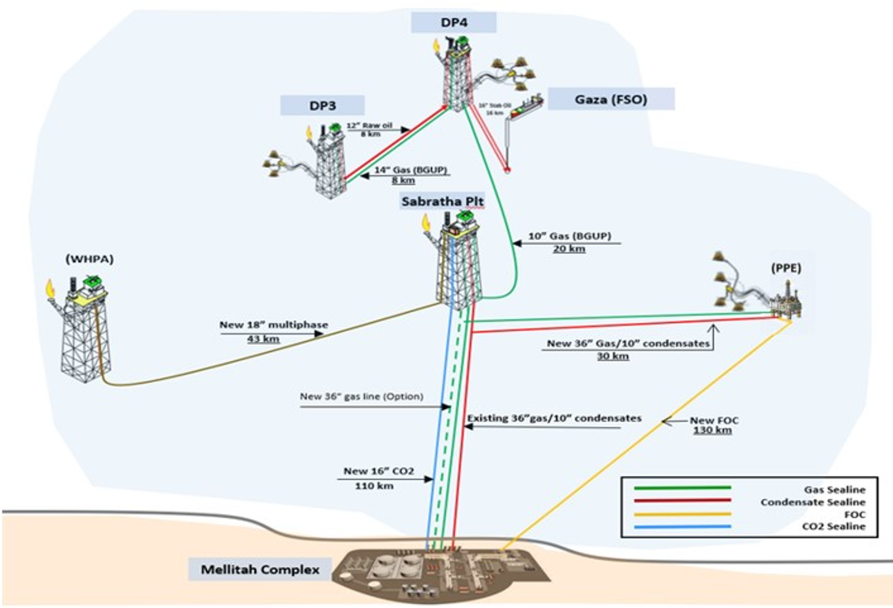

SCHEDULE
The EPC execution is expected to start by Q3 2027 and to be completed by Q2 2030 with supply of Xmas trees in the range of 24-26 months at SITE.
Associated Tendering process is planned to occur from Q4 2026 to Q3 2027

SCOPE OF WORK
It is a turnkey EPC Contract. The EPC Contractor’s Scope of Work includes as a minimum Endorsement of FEED, the Project Management, Administration, Surveys, material selection, detailed design, Engineering, Procurement, Manufacture, Fabrication, Testing, System Integration, Load-Out, Transportation, Pre-commissioning, Commissioning, support Other COMPANY’s EPIC Contractor during Installation, Tie-in, Hookup, Testing, Commissioning and Start-up and witness of Performance Test of the following subsea production systems:

- EPC for Subsea Production Systems (SPS) (WP4B3) (free issued or novated to PPE ”WP1”and WP4B1), supply of:

From West/North Clusters to PPE
- PPE North Cluster Manifold & West Cluster PLEM and foundation, including Transportation up to WP4B3 Malta Yard), Site Receival Test, Preservation and Load out . Offshore T&I by WP4B1.
- North & West Cluster Production X-Mas Trees (4-off XTs) w/ Multiphase Flowmeter, including Transportation (up to WP4B3 Malta Yard, Site Receival Test, Preservation and Load out. Offshore T&I by WP4B1).
- 2-off Subsea Isolation Valves (SSIVs), including Transportation up to WP4B3 Malta Yard, Site Receival Test, Preservation and Load out. Offshore T&I by WP4B1.
- 1-off SSIVs Control Umbilicals and related UTH, including Transportation up to WP4B3 Malta Yard, Site Receival Test, Preservation and Load out. Offshore T&I by WP4B1
- 2-off Field Umbilicals (~ 16 Km + ~ 7 Km) and related UTHs. Offshore T&I by WP4B1
- Hydraulic and Electrical flying leads, including Transportation up to WP4B3 Malta Yard, Site Receival Test, Preservation and Load out. Offshore T&I by WP4B1
- Subsea Production Control Systems Integrated in Subsea Structure.
- PPE Topside Subsea Production Control Systems (e.g. MCS, HPU, TUTU, Etc), including delivery to PPE WP1 Contractor Yards.
- PPE Topside Subsea Production Control Systems for SSIV, including delivery to PPE WP1 Contractor Yards.
- IWOCS, IWOCS tools and Landing String rental service, including transportation up to WP4B3 Malta Yard, Site Receival Test, Preservation and Load out. Offshore T&I by Drilling Contractor. Offshore support to operate IWOCS and Landing String.
- Subsea Tie-in Systems.
- ROV/divers tooling System;

From PPE to Sabratha Platform
- 2-off Subsea Isolation Valves (SSIVs), including Transportation up to WP4B3 Malta Yard, Site Receival Test, Preservation and Load out. Offshore T&I by WP4B1.
- 1-off SSIVs Control Umbilicals and related UTH, including Transportation up to WP4B3 Malta Yard, Site Receival Test, Preservation and Load out. Offshore T&I by WP4B1.
- Subsea Tie-in Systems.
- ROV/divers tooling System;

CO2 Network System

- Engineering, procurement and Supply of 1-off CO2 SSIV at Sabratha including riser base flange and counter flange including Transportation up to WP4B3 Malta Yard, Site Receival Test, Preservation and Load out (Optional). Offshore T&I by WP4B1.
- Subsea Tie-in System
- ROV/divers tooling System;

The above SoW includes all related functions, activities and services of each and every kind to accomplish the work, including as minimum; management, supervision, quality assurance, quality control, training, produce as-built drawings/documentation, compile record books, material handling/expediting, preservation, cost control, scheduling, status/progress reporting, interface with Company Marine Warranty Surveyor and Certifying Authority, interfacing with related facilities both Existing and New, interface management in general, provide all labour, resources, tools, equipment, plant, consumables, spares, vendor specialist assistance, accommodation and related infrastructure elements, local content, and implement all safety and environmental requirements.
The following work categories shall be part of the scope of work:

- HEALTH, SAFETY, ENVIRONMENT and QUALITY MANAGEMENT SYSTEMS

- PROJECT Management

- Engineering

- Procurement services

- Construction / FABRICATION / Pre-commissioning / Commissioning.

- Support Other COMPANY’s EPIC Contractors during installation / Connections / DIVER ASSISTED & DIVERLESS / TIE-INS AND Hook ups / Testing /START-UP

- Certification, Approvals, Consents and Permits

Important
For the execution of the work described above the Applicant must indicate which part of the scope shall be generated by the Applicant and which part of the scope will be generated by sub-contractors. Such sub-contractors need to be identified at this stage in order to be qualified.
Applicant to include a subcontracting plan identifying key suppliers and provide evidence of long-term agreements or letters of intent for critical scopes (e.g. Umbilical supplier, Topside control System, Workover System…).
In case of Consortium, a consortium agreement shall be provided (identify lead partner, financial responsibility split, liability allocation, decision-making preliminary rules).

It is required that the main core work shall be executed by the Applicant.

Only specialized and original manufacturers for similar oil and gas projects that have proven capability and extensive experience of supplying subsea systems and pipeline systems with specific expertise in offshore hydrocarbons similar projects will be considered to competitively Tender for the Scope of Work described above.

The Applicant shall demonstrate strong HSE and Quality performance factors in similar projects and provide their commitment to ensuring that all conducted on their behalf are carried out in a safe and efficient manner.

The Applicant shall present its track-record as well on similar project and supply.

The Applicant shall provide also a preliminary execution time line for supplying the requested material.

