**ENQUIRY FOR PREQUALIFICATION (NO. PRQ/JPT/034/24)**

**STRUCTURES A & E, MELLITAH COMPLEX EXPANSION & CO2 MANAGEMENT INTEGRATED DEVELOPMENT PROJECT**

**PPE PLATFORM**

Mellitah Oil & Gas B.V. (MOG) intends to enhance its production by adding new offshore and onshore production facilities, under STRUCTURES A & E, MELLITAH COMPLEX EXPANSION & CO2 MANAGEMENT INTEGRATED Development Project. The Overall Development will be implemented on individual projects basis; MOG would like to invite the interested EPCC (Engineering, Procurement, Construction and Commissioning) Contractors who are experienced in Offshore Production Fixed Platform systems to express their interest to participate in the Tender of EPCC, by submitting a Prequalification request to Company. Information about the Project and the Participation requirements are detailed here following.

**PROJECT DESCRIPTION**

The overall A & E structures development project foresees the exploitation of Structures A and E located in the Libyan offshore area of NC 41 Block. The “A” Structure is in the central-western part of the area, approximately 80 Km from Libyan coasts, where water depth is ranges between 95 and 105 m. While, “E” Structure is located in the central-eastern part of the area, about 130 Km far from the Libyan coast, in a water depth ranging from 205 to 235 m.

The selected offshore development scenario foresees:

* Structure A (WHPA): A New Wellhead Platform installed in 96m water depth (outside the scope of this pre-qualification)
* **Structure E (PPE):** **A New Production Platform installed in about 220 m water depth (inside the scope of this pre-qualification). Please refer to the “SCOPE OF WORK” section for further details.**
* Modification of Existing Sabratha Platform (outside the scope of this pre-qualification)
* Sealines and Subsea Systems for Structure A and E (outside the scope of this pre-qualification)
* The onshore development scenario foresees upgrade of the existing onshore Mellitah Complex (outside the scope of this pre-qualification).

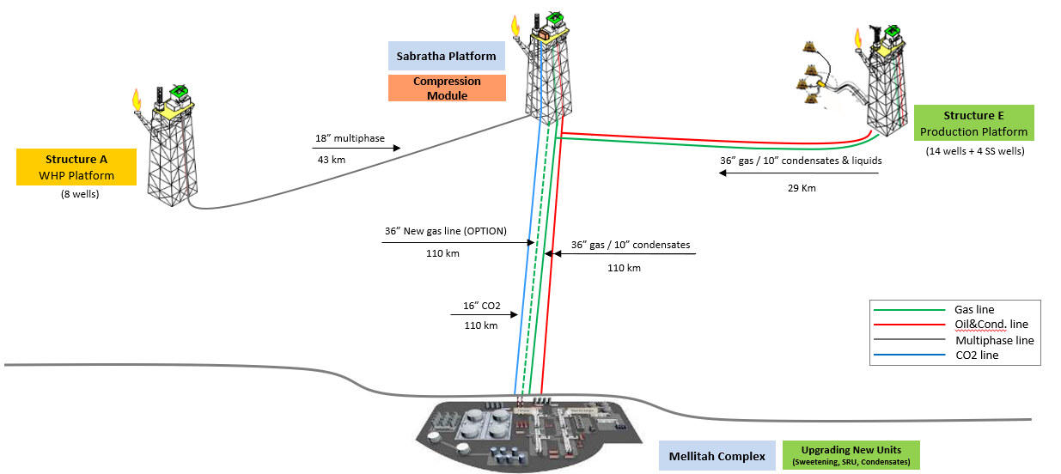

**SCHEDULE**

The EPCC execution is expected to start on 4Q 2025 following a Tendering process expected between 4Q 2024 and 3Q 2025.

**SCOPE OF WORK**

It is a turnkey EPCC Contract. The EPCC Contractor’s Scope of Work includes as a minimum the Project Management, Surveys, Engineering, Procurement, Construction, Fabrication, Testing, Integration Testing, onshore Commissioning, Load Out, offshore Hook up, Commissioning and Start-up (Transportation and Installation are outside the scope of work) of the following processing production fixed platform system inclusive of both Jacket and Deck:

* PPE (Production Processing Platform E) General information:
  + Location: Central-eastern part of Area D, 130 km offshore from Libyan coast
  + Design Life: 35 years
  + Water depth: 220 m (LAT)



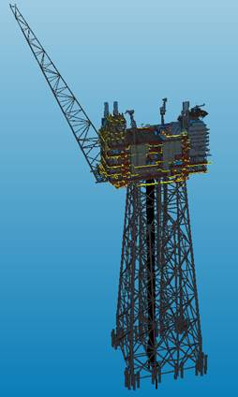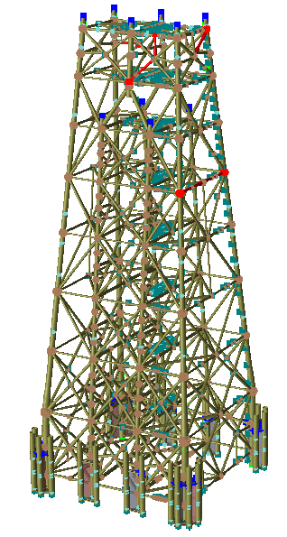

* Jacket description:
  + Jacket legs: No. 8
  + Height: 235 m
  + Wells slots: No. 20
  + Driven Piles: n. 28 (108"), 122÷125 m length (19,000t)
  + Top dimensions: 27m x 50m
  + Base dimensions: 70m x 78m
  + Launch weight: 43,000 – 45,000 t
  + Buoyancy tanks: 3,150 – 3,250 t (x2)

 

* Topside Description:
  + 600 MMSCFD of raw gas (C1 67%, CO2 14%, H2S 0.12%, N2 4%)
  + 30.000 BOPD of condensate
  + 20.000 bbl/day of water
  + Wells: 16 dry (14 gas) + 2 (spare) / 4 subsea wells (gas) + (spare connections), pre-drilled by a semisub rig using a subsea Pre Drilling Template, while wells re-entry, completion and further wells intervention performed by a Fast Moving Workover Rig (FMWR) to be relocated by the EPCC Contractor from the WHPA platform and to be installed onboard PPE to remain fixed on board; (FMWR outside the scope of this pre-qualification)
  + Dimensions: 95.0 m x 39.0 m (cellar deck) / Elevation: 44.0 m (sub-cellar/weather)
  + LQ with 120 PoB + helideck (height 33 m) + 2 cranes
  + Risers: 5 (10"/36"/16"/8"/4") + 3 (12" - spare for future tie-backs)
  + J-Tubes: 4 (2x10"/24"/8") + 6 (3x12"/3x24" - spare for future tie-backs)

|  |  |
| --- | --- |
|  |  |

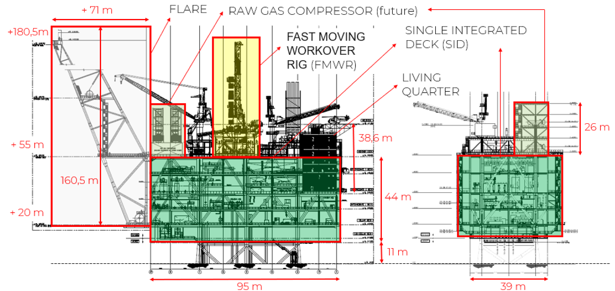

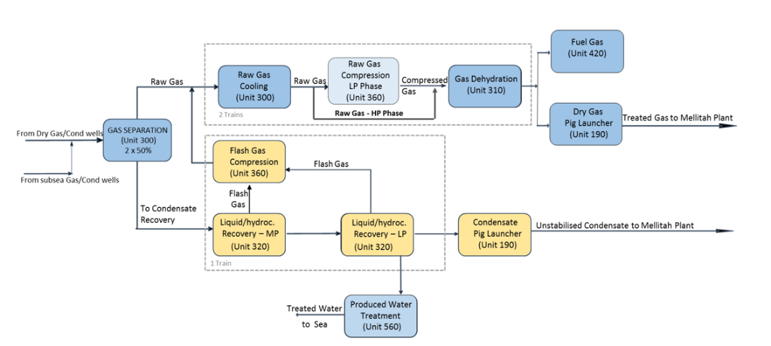

* Topside estimated gross dry lifting weights:
  + SID (Single Integrated Deck) *: 17.312 t
  + Offshore Installed Items 1.454 t
  + LQ (Living quarter): 3.194 t
  + Flare: 1.804 t
  + Raw Gas Compression (RGC) (future installation): 2.117 t
  + **Total: ~ 26000 t**

Note:

**\*** SID lift weight excludes Living Quarters, Flare, FMWR, future RGC module, Power Generation duct module, temporary pig traps, and items considered to be separately installed offshore (1.454 t) in the multiple lifting scenario. Instead, in the flaotover scenario, the overall total weight indicated above will be handled in a single lift with the possible exclusion of only the Flare.

* Topside installation (excluded from the EPCC object of this prequalification):s considered to be executed by a separate T&I Contractor by multiple Lifting (by HLV) or Float-over (not traditional but by catamaran crane vessel) methodology which is currently under final evaluation by COMPANY.

The above SoW includes all related functions, activities and services of each and every kind to accomplish the work, including as minimum management, supervision, quality assurance, quality control, training, produce as-built drawings/documentation, compile record books, material handling/expediting, preservation, cost control, scheduling, status/progress reporting, interface with T&I’s Contractor selected by Company, Company Marine Warranty Surveyor and Certifying Authority, interfacing with related facilities both Existing and New, interface management in general in particular with T&I Contractor, provide all labor, resources, tools, equipment, plant, consumables, spares, vendor specialist assistance, accommodation and related infrastructure elements, local content and implement all safety and environmental requirements.

The following main work categories shall be part of the EPCC scope of work:

* HEALTH, SAFETY, ENVIRONMENT and QUALITY MANAGEMENT SYSTEMS
* PROJECT Management
* Engineering
* Procurement services
* Construction / FABRICATION / LOAD OUT / TIE-INS AND Hook up / Testing / Pre-commissioning / Commissioning & Start-up
* provision of suitable Floatel to provide accomodation during offshore hook up and commissioning
* Certification, Approvals, Consents and Permits

**TRANSPORTATION AND INSTALLATION OF THE PLATFORM JACKET AND TOPSIDE ARE EXCLUDED FROM THE EPCC SOW AND OBJECT OF THIS PREQUALIFICATION AND ARE PERFORMED BY SEPARATE T&I CONTRACTOR/S WHICH WILL BE NOVATED UNDER THE EPCC.**

In addition to the marine operations to be part of this EPCC required for the relocation of the FMWR from WHPA to PPE platform and the supply of the floatel, it could be eventually included also other minor Installation activities depending on the selected installation methodology for the Platform topside and possible remaining minor lifts to be executed to finalize the integration of the platform offshore.

For the execution of the work described above the Applicant must indicate which part of the scope shall be generated by the Applicant and shall nominate only sub-contractors for those parts of the scope that are a major or significant need to be identified at this stage in order to be qualified.

In case of Consortium, a consortium agreement shall be provided. It is required that the main core work shall be executed by the Applicant.

Only specialized and original manufacturers for similar oil and gas projects that have proven capability and extensive experience of supplying production and processing offshore fixed platforms of similar size and weight of PPE will be considered to competitively Tender for the Scope of Work described above.

Contractor entities shall demonstrate strong HSE and Quality performance factors in similar projects and provide their commitment to ensuring that all activities conducted directly or on their behalf are carried out in a safe and efficient manner. Contractor shall present its performance record, statistics, and procedures over the last 10 years.