ENQUIRY FOR PREQUALIFICATION (NO. PRQ/JPT/29/23)

STRUCTURES A & E, MELLITAH COMPLEX EXPANSION & CO2 MANAGEMENT INTEGRATED DEVELOPMENT PROJECT

SEALINES AND SUBSEA SYSTEMS FOR WHPA TO SABRATHA PLATFORM

Mellitah Oil & Gas B.V. (MOG) intends to enhance its production by adding new offshore and onshore production facilities, under STRUCTURES A & E, MELLITAH COMPLEX EXPANSION & CO2 MANAGEMENT INTEGRATED Development Project. The Overall Development will be implemented on individual projects basis; including an EPIC Project for SEALINES AND SUBSEA SYSTEMS related to the production from WHPA to Sabratha Platform. MOG would like to invite the interested EPIC Contractors who are qualified and experienced in sealine and subsea systems to express their interest to participate in the Tender of EPIC, by submitting a Prequalification request to Company. Information about the Project and the Participation requirements are detailed here following.

PROJECT DESCRIPTION

The overall A & E structures development project foresees the exploitation of Structures A and E located in the Libyan offshore area of NC 41 Block. The “A” Structure is in the central-western part of the area, approximately 80 Km from Libyan coast, where water depth is ranges between 95 and 105 m. While, “E” Structure is located in the central-eastern part of the area, about 130 Km far from the Libyan coast, in a water depth ranging from 205 to 235 m.

The selected offshore development scenario foresees:
- Structure A (WHPA): A New Wellhead Platform installed in 96m water depth (outside the scope of this pre-qualification)

- Structure E (PPE): A New Production Platform installed in 220 m water depth (outside the scope of this pre-qualification)

- Modification of Existing Sabratha Platform (outside the scope of this pre-qualification)

- Sealines and Subsea Systems (inside the scope of this pre-qualification). Please refer to the “SCOPE OF WORK” section for further details.

- The onshore development scenario foresees upgrade of the existing onshore Mellitah Complex (outside the scope of this pre-qualification).

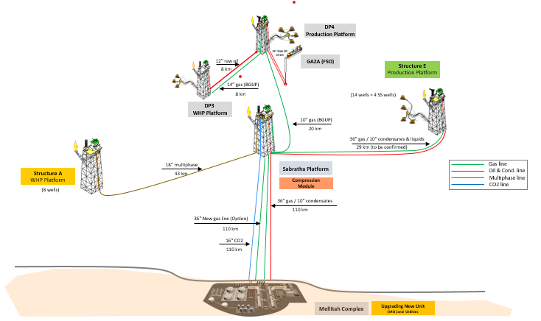
SCHEDULE
The EPIC execution is expected to start on 4Q 2024 and to be completed in 3Q 2027.

SCOPE OF WORK
It is a turnkey EPIC Contract. The EPIC Contractor’s Scope of Work includes as a minimum the Project Management, Surveys, Engineering, Procurement, Construction, Fabrication, Testing, Integration Testing, Load-Out, Transportation, Installation, Hook up, Pre-commissioning, Commissioning and Start-up of the following subsea and sealine systems:

- Subsea Production and Control Systems (SPCS):
- SSIV controls system including TOPSIDE control system.
- SSIV’s Umbilicals and related end terminations.
- Three SSIV systems and related protective structures & foundations.
- Electrical/Hydraulic Jumpers/Flying Leads and end terminations.
- Tooling (ROV, etc.)

- Fibre Optic Cables (FOC) and Umbilicals:
- A FOC from WHPA to Sabratha platform
- Two SSIV umbilicals to control respectively one and two SSIVs located at the respective Platforms.

- Cladded Sealine (excluding the procurement):
• 18” sealine (multiphase), 43 km from WHPA to existing Sabratha Platform. (Procurement of uncoated cladded pipeline material shall be outside the scope of this EPIC and this pre-qualification being considered a Company Provided Item).
- The scope of this EPIC include the design, procurement and application of the thermal insulation for this cladded pipeline.

The above SoW includes all related functions, activities and services of each and every kind to accomplish the work, including as minimum management, supervision, quality assurance, quality control, training, produce as-built drawings/documentation, compile record books, material handling/expediting, preservation, cost control, scheduling, status/progress reporting, interface with Company Marine Warranty Surveyor and Certifying Authority, interfacing with related facilities both Existing and New, interface management in general, provide all labour, resources, tools, equipment, plant, consumables, spares, vendor specialist assistance, accommodation and related infrastructure elements, local content, and implement all safety and environmental requirements.
The following work categories shall be part of the scope of work:

- HEALTH, SAFETY, ENVIRONMENT and QUALITY MANAGEMENT SYSTEMS

- PROJECT Management

- Engineering

- Procurement services
- Construction / FABRICATION / installation / Connections / DIVER ASSISTED & DIVERLESS TIE-INS AND Hook ups / Testing / Pre-commissioning / Commissioning & Start-up.

- Certification, Approvals, Consents and Permits

Important
For the execution of the work described above the Applicant must indicate which part of the scope shall be generated by the Applicant and shall nominate only sub-contractors for those parts of the scope that are a major or significant need to be identified at this stage in order to be qualified.
In case of Consortium, a consortium agreement shall be provided.

It is required that the main core work shall be executed by the Applicant.

Only specialized and original manufacturers for similar oil and gas projects that have proven capability and extensive experience of supplying subsea systems and pipeline systems with specific expertise in offshore hydrocarbons similar projects will be considered to competitively Tender for the Scope of Work described above.

Contractor entities shall demonstrate strong HSE and Quality performance factors in similar projects and provide their commitment to ensuring that all marine activities at site (including diving and ROV operations) conducted on their behalf are carried out in a safe and efficient manner. Contractor shall present its performance record, statistics and procedures for all Diving and ROV, Vessel operations over the last 5 years with reference to International Marine Contractor Association (IMCA) guidelines.

