1. INTRODUCTION:
Mellitah Oil and Gas (MOG) Libyan Branch invites international and local companies specialized in Certification & Verification Services and Marine Warranty Surveyor, to be prequalified for inclusion in the bidders list of the tender to be issued for the provision of Certification & Verification Services and Marine Warranty Surveyor for Structures A & E, Mellitah Complex Expansion & CO2 Management Integrated Development Project facilities in compliance with Libyan and International standards.

2. PROJECTS DESCRIPTION:
Company is considering the development scenario for A-Structure located in the Libyan offshore (Area D) envisages a dry tree/fixed platform development in synergy with the existing platform of Sabratha, while the E-Structure will be developed using an independent fixed production platform along with subsea wells.
E-Structure is located (see figure below) in the central-eastern part of the Area D (ex NC41 area), about 130 Km far from the Libyan coast, in a water depth ranging from 205 to 235m, while A-Structure is in the central-western part of the area, approximately 80 Km from Libyan coast, where water depth is ranging between 95 and 105m.
A new 36” gas sealine about 30 km long (size and distance to confirmed) to deliver E Structure production to existing 36” gas export sealine from Sabratha Platform to Mellitah Complex.
A new 10” condensate sealine about 30 km long (size and distance to confirmed) to deliver E Structure production to existing 10” condensate export sealine from Sabratha Platform to Mellitah Complex.
A new 18” multiphase flow line from WHPA to Sabratha Platform and 16” multi phase gathering line to tie-back the subsea wells to PPE.
Sabratha Platform modification (manifold and separation for A Structure production).
New 4th SRU train and associated new utilities together with upgrade of the existing gas trains and existing SRU trains and associated utility systems with the purpose of improving reliability, availability, productivity, efficiency and extending design life in line with established production profile.
CO2 management through dehydration and compression in Mellitah and injection in 3 wells in BES field through the installation of a new sealine (16”) 110 km from shore to BES field.
The overall Project scheme is summarized in the sketch drawing below.
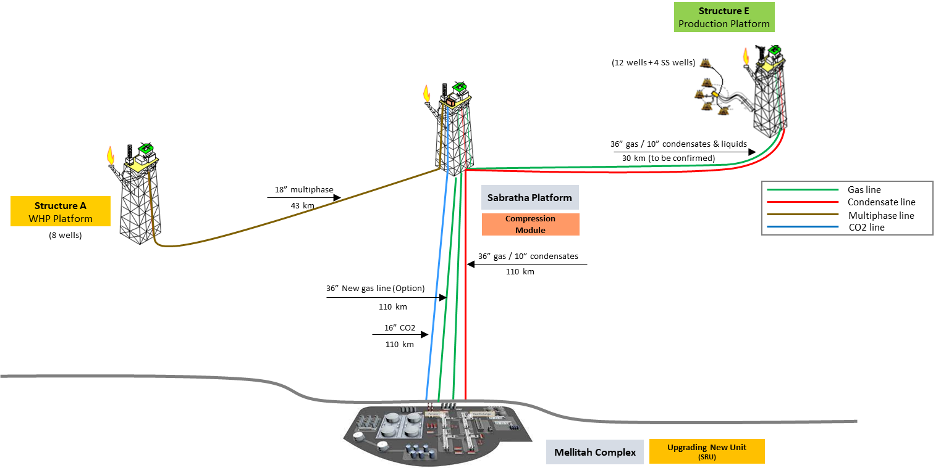
A-Structure and E-Structure, Mellitah Complex Expansion & CO2 Management Development Scheme
3. OBJECTIVES:
The objective of Certification & Verification services and Marine Warranty Surveyor is to provide assurance that the regimes laid down in the applied project specifications, codes and standards in all stages are met during the design, construction and installation phases of the Project (systems) and subsequently maintained during the operation phase, and satisfy the minimum requirements of the involved Certifying Authority.

4. SCOPE OF WORK
4.1 SCOPE OF WORK for Certification & Verification Services
- Review and verification of the work activities executed by COMPANY's EPC/EPIC Contractor (s) during the Detailed Engineering, Procurement, fabrication, construction, transportation, installation, hook-up and commissioning to the start-up of the Structures A & E & Mellitah Complex Expansion Project for the following work packages:

1. Pre-drilling Templates (PDTs) for WHPA & PPE - EPIC
2. Subsea & Sealines - EPIC
3. Onshore Mellitah Complex Expansion – EPC
4. Well Head Platform A (WHPA) – EPIC
5. Sabratha Modification for Structure A – EPIC
6. Production Platform E (PPE) – EPIC

- To attend fabrication / assembly sites and offshore site as necessary to carry out pre­ operation inspections and witness of actual operations.
- Attend risk assessment and HAZOP meetings as necessary.
- The Certifying Authority (CA) shall review, comment, and accept the work design. The CA shall be involved through out the EPC/EPIC execution phases at work sites and attend / carry out necessary inspection and witness tests as identified in the SoW.

- The Contractor as independent Certifying Authority (CA) shall be satisfied that the relevant project specifications, codes, national and international standards have been complied with.
The Certifying Authority's satisfaction that the required project specifications, standards and codes have been complied with shall be signified by the issue of:

  - Confirmation in the form of a "Release Note" for each stage confirming that the review and verification process has been completed and the relevant requirements at this stage have been satisfied.
Upon completion certificate(s) of fitness shall be issued for each component of the project as listed in the scope of work.
4.2 SCOPE OF WORK for Marine Warranty Surveyor
- Review / comment / accept EPIC Contractor marine operation procedures and other relevant and supporting documentation in respect of load-out, sea fastening, transportation and offshore installation activities.
- For all related marine equipment, M.W.S. shall review relevant specifications and carry out inspections/surveys as necessary in order to confirm suitability and fitness for purpose.
- To attend fabrication / assembly sites and offshore site as necessary to carry out pre­ operation inspections and witness of actual operations.
- Attend risk assessment and HAZOP meetings as necessary.
- To issue the relevant CERTIFICATES OF APPROVAL for:
- LOADOUT
- TRANSPORTATION
- OFFSHORE INSTALLATION
- ONSHORE OFFLOADING AT THE MATERIAL OFFLOADING FACILITY (MOF) (TO BE AGREED).

