ENQUIRY FOR PREQUALIFICATION (NO. PRQ/JPT/22/21)

BOURI GAS UTILIZATION PROJECT (BGUP)

TECHNICAL CONSULTANCY SERVICES (TCS)

Introduction

Project Objectives

The objective of BOURI GAS UTILIZATION PROJECT is to supply and install a Gas Recovery Module (GRM) and ancillary structures/modules at the offshore Bouri field together with the associated sealine gathering network and supporting infrastructure to export gas to the onshroe Mellitah Complex via the existing Sabratha Offshore platform network. This WORK includes the necessary upgrades at Bouri DP4 Living Quarter.

Execution Strategy

COMPANY will award an EPCIC contrcator responsible for the Engineering, Procurement, Construction, Transportation, Installation, Hook-up, Pre-Commissioning, Mechanical completion, Commissioning, Start-Up and Performance Testing of all facilities associated with the Bouri Gas Utilisation Project. EPCIC contrcator scope or work includes all necessary activities and provision to obtain Independent Verification Body (IVB), Marine Warranty Surveyor (MWS) and COMPANY approval for the planning and execution of WORKS and safe operation of the FACILITY.

COMPANY will be in charge for the overall management and follow-up (review/approval) of the EPCIC Contractor works till the ready for gas-in phase when COMPANY will take charge to lead the final commissioning and performance test with support of EPCIC contractor. COMPANY activities will be accomplished by means of an execution team made of COMPANY’s personnel in the key positions and Technical Consultancy Services (TCS) to secure all additional resources and services not available within the COMPANY, working as an integrated team.

Depending of the final selected EPCIC bidder, the works will executed in different location (i.e. countries), however the EPCIC strategy will consider at least a Management main office, Subsea/pipeline scope engineering office, Main fabrication yard for Gas recovery Module (about 5000 tons), secondary fabrication yard for ancillaries close to the Bouri field area, offshore works for Living Quarter Upgrading, facilities preparation and hook-up, offshore installation campaign. All such activities shall be follow-up by the COMPANY integrated team (i.e. COMPANY and Technical Consultancy Services) in accordance to the agreed surveillance requirements with the EPCIC contractor.

Existing Bouri Facilities Overview
The Bouri oil field is in the Mediterranean Sea, approximately 120 km northwest of Tripoli. Currently it is producing oil at a rate of approx. 30,000 bopd of low API gravity crude (25°-27° API), associated gas, and produced water from facilities located on two existing platforms, DP3 and DP4, operated by Mellitah Oil and Gas (MOG).
DP3 is a satellite production platform with 21 platform wells and 3 subsea wells connected to a single stage of 2-phase separation.. Production liquids (containing crude oil and water) free flow to the 2nd stage separators on the main DP4 processing platform via an existing 12” x 8 km marine pipeline. Currently, DP3 oil production is in the region of 15,000 bopd.
DP4 has 42 connected platform wells and handles production fluids from these along with the production liquids from DP3 via two trains. These trains were originally designed to operate in parallel to each produce 60,000 bopd for a total platform capacity of 120,000 bpd (i.e. 2 x 50%). Each train consists of three stages of 3-phase separation and an electrostatic desalter. Stabilised oil is pumped to an existing FSU called ‘Gaza’ via 1 x 100% 16” x 3 km marine pipeline. Produced water is treated to reduce its oil content to 15 ppm and either re-injected into the Bouri reservoir or discharged to sea. Currently, wells on DP4 produce approx. 15,000 bopd, giving total production (including DP3 fluids) in the region of 30,000 bpd.

Figure 1-1: DP4 Platform

BGUP FACILITES UPGRADES SCOPE OF WORK (by EPCIC contractor)
The BGUP reactivation study (performed by Wood in 2019) resulted in a simplified process arrangement for the Bouri gas utilisation project with a gas recovery module being installed on the DP4 platform alongside a series of essential brownfield upgrades to both DP3 and DP4.
Raw gas taken off the DP3 separator will be transferred to DP4, via a new 14" x 8km Inconel clad pipeline. To accommodate this, the following modifications are proposed for the DP3 platform:
- Process tie-ins from existing production separator, test separator and gas scrubber.
- A small hang-off module to accommodate a new pig launcher and interconnecting facilities.
- New riser for the 14” infield pipeline.
The DP3 raw gas will be mixed with raw gas taken off the DP4 separator trains and this combined raw gas stream will be compressed via a 4-stage centrifugal compressor (General Electric BCL model) and dehydrated (via silica gel beds located between the 3rd and 4th stages) for export at approximately 110 barg. The compressor will be powered by a gas turbine (General Electric PGT25 SAC model) which cannot operate effectively using the available raw gas. Accordingly, higher quality fuel gas will be provided by taking a slip stream of the raw gas downstream of the dehydrators (between the 3rd and 4th compression stages) and passing it through an acid gas removal unit (membrane system). Condensate separated in the raw gas treatment and compression systems is spiked into oil train for export to the Gaza FSU. To accommodate this, the following modifications are proposed for the DP4 platform:
- Gas Recovery Module (single lift, NTE 5,000 Te)
- Process and Utility tie-ins to existing DP4 facilities
- Pig receiver and 14” riser to receive DP3 raw gas via infield pipeline
- Pig launcher and 10” riser to export Bouri raw gas to Sabratha platform
The pressurised raw gas from DP4 is transferred to Sabratha platform (via a new 10" x 20km carbon steel pipeline) for onward export to Mellitah onshore plant (via an existing 36" x 110km pipeline). The platforms are protected by an export and import SSIS for each pipeline together with Fibre Optic Cables for interconnection between DP3, DP4 and Sabratha Platforms.

The proposed field layout incorporating the BGUP facilities is shown in Figure 1-2.
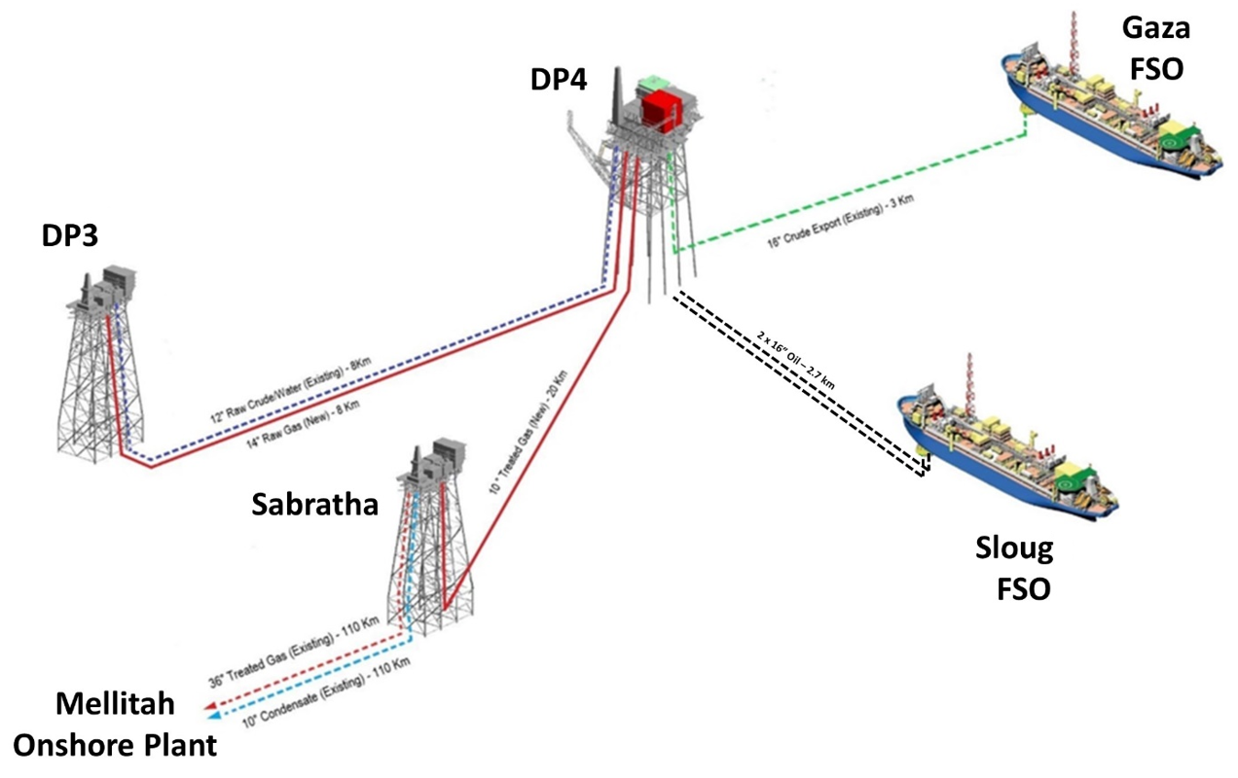
Figure 1-2 Bouri Field Layout Including Proposed BGUP Facilities Upgrades

In addition to the 14” Raw Gas Sealine from DP3 to DP4 Platform and 10” Export Gas Sealine from DP4 to Sabratha Platform, the subsea scope includes the provision of SSIS’s as well as new Risers and J-Tubes for the connection of sealines and Fibre Optic Cables (FOC) and umbilicals at DP3 and DP4.

SCHEDULE
Engineering, Procurement, Construction, Installation and Commissioning (EPCIC) Project. The EPCIC execution is expected to start in 2Q 2022 with overall completion in 2024.The Technical Consultancy services subject of this prequalification SOW as better indicated below are expected to be effectived from the 3Q/4Q 2022.

TECHNICAL SERVICE SCOPE OF WORK

GENERAL
Mellitah Oil & Gas B.V. (MOG) intends to execute the Bour Gas UtilizationP project mentioned above. Experienced and qualified organisations are invited to submit a Prequalification questionaire to register interest in being included in a List of Tenderers for Technical Consultancy Services (TCS) Contractor.

The Scope of Work of the TCS CONTRACTOR is to provide personnel and services suitable to perform the activities described in SERVICES TO BE PERFORMED BY TC CONTRACTOR. The Technical Consultancy Services (TCS) CONTRACTOR will operate under the direction and control of COMPANY's management and will integrate COMPANY'S team.

TCS CONTRACTOR particularly warrants that each and every engineer to be assigned for the work will be duly qualified, experienced, skillful, fully familiar will all applicable standards, codes, and specifications and can indeed provide all necessary comments, elaborations, and recommendations within the contractual timeframe

SERVICES TO BE PERFORMED BY TCS APPLICANT:

COMPANY PROVIDED ITEM and EPCIC’s PROCUREMENT:

TC Applicant shall provide competent personnel to be integrated with COMPANY project team in order to coordinate the QA/QC activities, participate to inspections and carry out expedite services in all Countries as required. The Main tasks will consist of:
- Review EPCIC’s contractor, CPI and vendor’s QA/QC documents including QA plan, QC plan, ITPs, test plans, test cases, test report and manage in the NCRs
- Coordinate the inspection and expedite
- Oversee and ensure contractor implementation of Quality plan, ITP and Quality procedures.
- Performing the inspections and expedite for intermediate steps and final acceptance test (FAT, SAT) by means of locally recruited qualified personnel in all countries involved in the supply of EPCIC materials and equipment
- Monitor the procurement, inspection and expediting and material control activities of Contractors;

ONSHORE FABRICATION AND CONSTRUCTION, LOAD-OUT, OFFSHORE TRANSPORT, OFFSHORE INSTALLATION AND HOOK-UP –
TCS CONTRACTOR shall provide competent personnel to be integrated with COMPANY project team in order to Monitor, co-ordinate, and follow up during onsite construction, offsite fabrication, installation, hook-up, commissioning, performance testing to ensure that operations are HSEQ compliant, technically sound and that all facilities are completed on time allowing a timely start-up of production. EPMT will perform the following;
- Coordinate all interfaces between all parties including those managing upstream and downstream activities to ensure efficient execution;
- ReviewContractor’s Construction Procedures;
- Audit Contractors construction inspection and approval process;
- Reviewprograms and construction methods;
- Communicate the need for and evaluate the impact of any changes proposed;
- Monitor and audit all inspection activities;
- Reviewapprove designs and method relating to transportation and installation
- witness all installation surveys and installation activities by means of qualified Company Site reppresentative and field engineers
- Site supervision and inspection of the works (all discipline) to full fil the Mechanical completion requirements inclusing witness and sign the Inspection Forms and punch list. Such services are rendered onshore and offshore

INSPECTION, TESTING, COMMISSIONING AND ACCEPTANCE - TCS CONTRACTOR shall provide competent personnel to be integrated with COMPANY project team in order to Monitor, co-ordinate, follow up and assist during testing, commissioning, etc., of the production facilities. EPMT will perform the following services:
- Check that all procedures and operating manuals for testing, commissioning start-up, performance testing, emergency etc., are duly prepared, commented and approved in accordance with the overall time schedule;
- Participate in system walkdowns, develop MOG punchlists, manage system turnovers ready for performance testing and start-up;
- Check that all testing Certificates, final certificates, are duly prepared, and duly signed by all concerned parties;
- Witness and sign all commissioning tests Forms; review the Punch list items

Construction Yard QC activities - TCS CONTRACTOR shall provide competent personnel to be integrated with COMPANY project team in order to guarantee QC during the onshore and offshore fabrication activities, Main tasks consist:
- Performing and coordinating inspections for materails traciability, welding, NDE, painting and coating
- Oversee and ensure contractor implementation of Quality plan, ITP and Quality procedures.
- Ensure compliance with the project specification, code and standards through daily surveillance and random inspection of the work as applicable
- Pipeline CPI line pipes inspection and re-coating inspections

PROJECT CONTROL SERVICES – TCS CONTRACTOR shall provide competent personnel to be integrated with COMPANY project team in order to support in following tasks :
- Review EPCIC project planning, control and reporting package including progress measurement policy and procedures including those to be utilised by Contractors
- Development and implementation of Risk management procedures.
- Develop and maintain an overall plan for the entire Project;
- Prepare COMPANY monthly progress report on the basis of EPCIC reporting
- Develop project cost Control System and procedures;
- Prepare the Overall Project Cost Reports;
- Administrate MOG document management functions.

CONTRACT MANAGEMENT - TCS CONTRACTOR shall provide competent personnel to be integrated with COMPANY project team in order to support in following tasks:
- Review of EPCIC contract adminstration and invoicing procedure
- General Contract Adminstration of the EPIC Contracts

QUALITY ASSURANCE - Development and implementation Quality Assurance MOG Procedures and Regulatory compliance management. The TCS CONTRACTOR shall assist the COMPANY to:
- Ensure that all parts of the PROJECT FACILITIES as delivered and operated will conform to the quality and safety standards required by COMPANY, and local authorities during development and throughout their operating life. It will also ensure that PROJECT certification requirements are met.
- Review all Quality assurance documents/records (such as spec's for Design, manufacture and installations and the Quality Systems implemented) and cross reference them to the project in order to provide identification and complete traceability.
- Perform QA Audits to EPCIC Contractor and its subcontractors as requiered

SAFETY - Development and implementation of HSE MOG Procedures and Regulatory compliance management. The TCS CONTRACTOR shall assist the COMPANY to:

- Ensure that all parts of the PROJECT FACILITIES as delivered and operated will conform to the quality and safety standards required by COMPANY, and local authorities during development and throughout their operating life. It will also ensure that PROJECT certification requirements are met.
- Develop the project HSE plan
- Review EPCIC Contractor and its subcontractor HSE plans, procedure and ensure compliance with COMPANY specification
- Prepare HSE bridging documents for the offshore works
- Review/prepare SIMOPS and CONOPS manual
- Participate to HAZID and HAZOP session
- Environmental Requirement - Carry out any work or services in connection with the environmental requirements of the PROJECT. To affect this work, there shall be among CONTRACTOR's personnel an environmental specialist that shall be versed in the governmental and international regulations concerning ecology, effluent discharges and treatment of process materials and waste disposal.
- HSE statistic reporting
- Perform HSE Audits to EPCIC Contractor and its subcontractors as required.
- HSE site (onshore and offshore) coordination and supervision

TCS Contractor will be responsible for its own internal business management functions as Indirects (Overheads) including; Corporate Management; Legal functions; Accounting functions including invoicing, record keeping and internal reporting etc.; Human Resources management including recruitment, staff employment issues and welfare etc.

