ENQUIRY FOR PREQUALIFICATION (NO. PRQ/JPT/19/21)

STRUCTURES “A” & “E”, MELLITAH COMPLEX EXPANSION & CO2 MANAGEMENT INTEGRATED DEVELOPMENT PROJECT

SABRATHA PLATFORM MODIFICATIONS

Mellitah Oil & Gas B.V. (MOG) intends to enhence its production by adding new offshore and onshore production facilities, under STRUCTURES A & E, MELLITAH COMPLEX EXPANSION & CO2 MANAGEMENT INTEGRATED Development Project. The Overall Development will be implemented on individual projects basis; including an EPIC Project for SABRATHA PLATFORM MODIFICATIONS. MOG would like to invite the interested EPIC Contractors who are qualified and experienced in the field of the subject project to express their interest to participate in the Tender of EPIC, by submitting a Prequalification request to Company. Information about the Project and the participation requirements are detailed below.

PROJECT DESCRIPTION

The overall A & E structures develeopment project foresees the exploitation of Structures A and E located in the Libyan offshore area of NC 41 Block. The “A” Structure is in the central-western part of the area, approximately 80 Km from Libyan coast, where water depth is ranges between 95 and 105 m. While, “E” Structure is located in the central-eastern part of the area, about 130 Km far from the Libyan coast, in a water depth ranging from 205 to 235 m.

The selected offshore development scenario foresees:

- Structure A (WHPA): A New Wellhead Platform installed in 96m water depth (outside the scope of this pre-qualification)

- Structure E (PPE): A New Production Platform installed in 220 m water depth (outside the scope of this pre-qualification)

- Modification of Existing Sabratha Platform

- Sealines and Subsea Production Systems (outside the scope of this pre-qualification)

- The onshore development scenario foresees upgrade of the existing onshore Mellitah Complex (outside the scope of this pre-qualification).

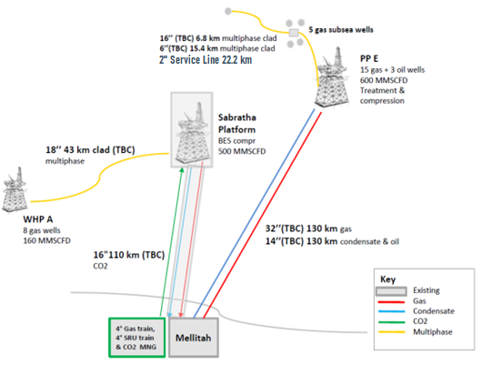

SCHEDULE

The EPIC execution is expected to start on 1Q 2023 and to be completed in 2Q-3Q 2024.

SCOPE OF WORK

It is a turnkey EPIC Contract. The EPIC Contractor’s Scope of Work includes Project Management, Surveys, Engineering, Procurement, Manufacturing/Construction, Fabrication, Testing, Transportation, Installation, Hook up, Pre-commissioning, commissioning, and Start-up of the following systems:

- New Separation Module:
- Approximetly Weigh Module equals to 950-1000 ton;
- Module is made by a separator (slug cathcer – two pahse separation) with associated connections to the existing facilities (gas and liquid line plus conncetions to the existing utilities systems as flare/open/closed&open drain/fire fighting/instrument air etc);
- Electrical and Instrumentaiton connections

- CO₂ injection facilities:
- 14” CO₂ Injection Manifold and connections to 5 existing wells and new CO₂ vent;
- Conncetions to the existing utilities systems;
- Electrical and Instrumentation connections.

- Brownfiled SoW:
- New boundle which includes: support caisson dia.1200 mm / 16” CO₂ Riser / 18” Riser for new WHPA sealine / 2 J-tubes to be installed along Sabratha jacket;
- Risers & J-tubes bundle protection frame structure;
- Provision for temporary pig receiver for the new WHPA sealine (WHPA and sealines outside the scope of this pre-qualification);
- Provision for pig receiver for the new CO₂ sealine in the arrival CO₂ sealine from onshore (CO₂ sealine outside the scope of this pre-qualification);
- 2 x100% Methanol Injection Pumps;
- 2 x100% Methanol Pumps;
- 2 x100% MEG Pumps;
- Upgrading of ICSS;
- Upggrading of Electrical system and Electrical Control Monitoring System for the users required for the SoW
- Telecommunication system for WHPA interface.

Including all related functions, activities and services of each and every kind to accomplish the work, including management, supervision, quality assurance, quality control, training, produce as-built drawings/documentation, compile record books, material handling/expediting, preservation, cost control, scheduling, status/progress reporting, interface with Company Marine Warranty Surveyor and Certifying Authority, interfacing with related facilities both existing and new, provide all labour, resources, tools, equipment, plant, consumables, vendor specialist assistance, accommodation and related infrastructure elements and implement all safety and environmental requirements.
The following work categories shall be part of the scope of work:

- SAFETY MANAGEMENT SYSTEMS

- PROJECT Management

- Engineering

- Procurement services
- Construction / FABRICATION / HLV installation / Connections / Testing / Pre-commissioning / Commissioning & Start-up.

- Certification, Approvals, Consents and Permits

Important
For the execution of the work described above the Applicant must indicate which part of the work shall be executed by the Applicant and which will be sub-contractored.

In case of Consortium, a consortium agreement shall be provided.

It is required that the main core work shall be executed by the Applicant.

Only specialized and original manufacturers for similar oil and gas projects that have proven capability and extensive experience of supplying offshore hydrocarbons of similar facilities will be considered to competitively Tender for the Scope fo Work described above.

Contractor entities shall demonstrate strong HSE performance factors in similar projects and provide their commitment to ensuring that all operations conducted on their behalf are carried out in a safe and efficient manner. Contractor shall present its performance record, statistics.

.

