ENQUIRY FOR PREQUALIFICATION (NO. PRQ/JPT/xx/21)

STRUCTURES A & E, MELLITAH COMPLEX EXPANSION & CO2 MANAGEMENT INTEGRATED DEVELOPMENT PROJECT

PROJECT MANAGEMENT SERVICES (PMS)

Mellitah Oil & Gas B.V. (MOG) intends to add new offshore and onshore production facilities, under Structures A & E, Mellitah Complex Expansion & CO2 Management Integrated Development Project. The Overall Development will include a range of EPC and EPIC Projects for Offshore (2 new platforms, 1 platform upgrade, subsea pipelines) and Onshore (new facilities for Mellitah Complex). Experienced and qualified organisations are invited to submit a Prequalification questionaire to register interest in being included in a List of Tenderers for Project Management Services (PMS) Contractor.

PROJECT DESCRIPTION
A Structure: New Wellhead Platform installed in about 95m, Export to existing Sabratah Platform through multiphase sealine 43km (18”) for treatment and compression.
E Structure: New Production Platform installed in about 218m, 18 dry tree wells (including 3 oil rim) + 5 subsea wells Peak production 600 MMSCFD. Export to shore through two sealine 130km for gas and oil/condensate.
Mellitah Complex: New 4th Gas Train, new 3rd Condensate train & new 4th SRU,
CO2 injection to Sabratha (compressor + 110 km 16” sealine to Sabratha).
Sabratha Platform Modifications: A structure treatment, compression & export to Mellitah through existing sealines, new slugcatcher, 2 new pig traps.
Interfaces with other Projects: Bouri GUP, Sabratha Oily Water system upgrading, Sabratha Compression Module and others
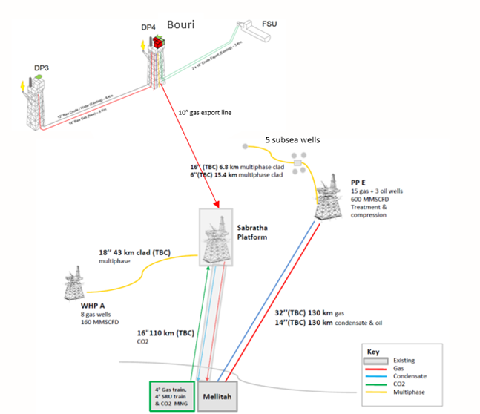

DEVELOPMENT SCENARIO
New Well-Head Platform (WHPA) Platform in 95m water depth.:
- 160MMSCFD gas, 12kSTB/d peak condensate, 8 gas/condensate wells
- Export to Sabratha
New Processing and Compression Platform (PPE) Platform in 218m water depth:
- 600MMSCFD gas, 30kSTB/d condensate, 5kbopd, 23 wells (20 gas + 3 oil).
- Gas and condensate/oil separately exported to Mellitah
- Two 130 km, 32” and 14” export sealines to MCX
- 18 dry tree wells (15 gas + 3 oil), 5 subsea gas wells
Sabratha Production Platform Modifications:
- A Structure treatment, compression & export in synergy with Sabratha Platfrom
- Separation, Dehydration, Compression
- Export to shore gas and condensate through 110 km sealines, 36” and 10”
- One new slug catcher and 2 new pig traps
- SIM, PIM & Topside Integrity activity
- CO2 reinjection in reservoir
Subsea & Sealine:
- Flow Assurance, Subsea Wells and Structures, Intrafield and Export Pipelines
- 18” multiphase sealine for treatment and future compression 43 km WHPA – Sabratha
- 32” & 14”, 130 km Pipelines from PPE to MCX
- 5 Subsea Wells, SSIVs, Intrafield Flowlines from Subsea Wells to PPE
- 16”, 107 km CO2 Transport Line from MCX to Sabratha
Mellitah Expansion and CO2 Management:
- 4th Gas train, 3rd Condensate train, 4th SRU train, CO2 Management, New Utilities
- Processing raw gas and unstabilized condensate
- Existing overall gas processing capacity of 1,100 MMSCFD.
- 4th New Gas train capacity 367 MMSCFD, 3 trains normally operating
- 2x50% multistage CO2 compressors and dehydration

SCHEDULE
Basic Design and FEED will provide basic design documents for inclusion in Invitations to Tender for Onshore Engineering, Procurement and Construction (EPC) and Offshore Engineering, Procurement, Installation and Commissioning (EPIC) Projects. The PMS, EPC and EPIC execution is expected to start in 1Q 2023 with overall completion in 20??.

SCOPE OF WORK
MOG shall form an Execution Project Management Team (EPMT) that will be led by MOG’s Project General Manager to whom the EPMT Project Managers of sub-packages (EPC, EPIC) and their associated teams shall report.

The EPMT scope of work does not include the execution of EPC and EPIC scopes, activities concerning drilling and completion's operations, and Certification Services.

The PMS Contractor shall provide EPMT members to participate in the integrated team providing a comprehensive Project Management Service including the following:

DETAILED ENGINEERING - Ensure the delivery of soundly engineered, HSEQ compliant facilities on time and within budget. EPMT will perform the following:
- Review, comment, reject or approve Contractor’s engineering and design procedures.
- Ensure interfaces between all parties are adequately defined and controlled.
- Review, comment, reject or approve Contractors design deliverables.
- Development and implementation of a technical management of change procedure.
- Participate in and contribute to design review process.

ONSHORE FABRICATION AND CONSTRUCTION, LOAD-OUT, TRANSPORT, INSTALLATION AND HOOK-UP - Monitor, co-ordinate, and follow up during onsite construction, offsite fabrication, installation, hook-up, commissioning, performance testing to ensure that operations are HSEQ compliant, technically sound and that all facilities are completed on time allowing a timely start-up of production. EPMT will perform the following;
- Coordinate all interfaces between all parties including those managing upstream and downstream activities to ensure efficient execution;
- Review, comment, reject or approve Contractor’s Construction Procedures;
- Audit Contractors construction inspection and approval process;
- Review, comment, reject or approve programs and construction methods;
- Communicate the need for and evaluate the impact of any changes proposed;
- Monitor and audit all inspection activities;
- Review, comment, reject or approve designs relating to transportation and installation, witness all installation surveys and activities;

TESTING. COMMISSIONING AND ACCEPTANCE - Monitor, co-ordinate, follow up and assist during testing, commissioning, etc., of the production facilities. EPMT will perform the following services:
- Check that all procedures and operating manuals for testing, commissioning start-up, performance testing, emergency etc., are duly prepared, commented and approved in accordance with the overall time schedule;
- Participate in system walkdowns, develop MOG punchlists, manage system turnovers ready for performance testing and start-up;
- Check that all testing Certificates, final certificates, are duly prepared, and duly signed by all concerned parties;
- Witness and sign all commissioning tests;

PROJECT CONTROL SERVICES
- Development and implementation of Risk management procedures.
- Develop planning and progress measurement policy and procedures including those to be utilised by Contractors;
- Develop and maintain an overall plan for the entire Project;
- Prepare monthly progress report.
- Develop project cost Control System and procedures;
- Prepare the Overall Project Cost Reports;
- Administrate MOG document management functions.

PROCUREMENT & CONTRACT MANAGEMENT - The services to be performed include the following:
- Management and Administration of EPC and EPIC Contracts.
- Monitor the procurement, inspection and expediting and material control activities of Contractors;

QUALITY ASSURANCE/CERTIFICATION AND SAFETY - Development and implementation of HSE, Quality Assurance and Control (QA/QC) Procedures and Regulatory compliance management.

PMS Contractor will be responsible for its own internal business management functions as Indirects (Overheads) including; Corporate Management; Legal functions; Accounting functions including invoicing, record keeping and internal reporting etc.; Human Resources management including recruitment, staff employment issues and welfare etc.

